Appling for a Proof of Insurance Certificate

These certificates are provided from BFL Canada. You may require this certificate if your team is holding an event and the facility is asking for proof of insurance.
These certificates are processed online through the following link:
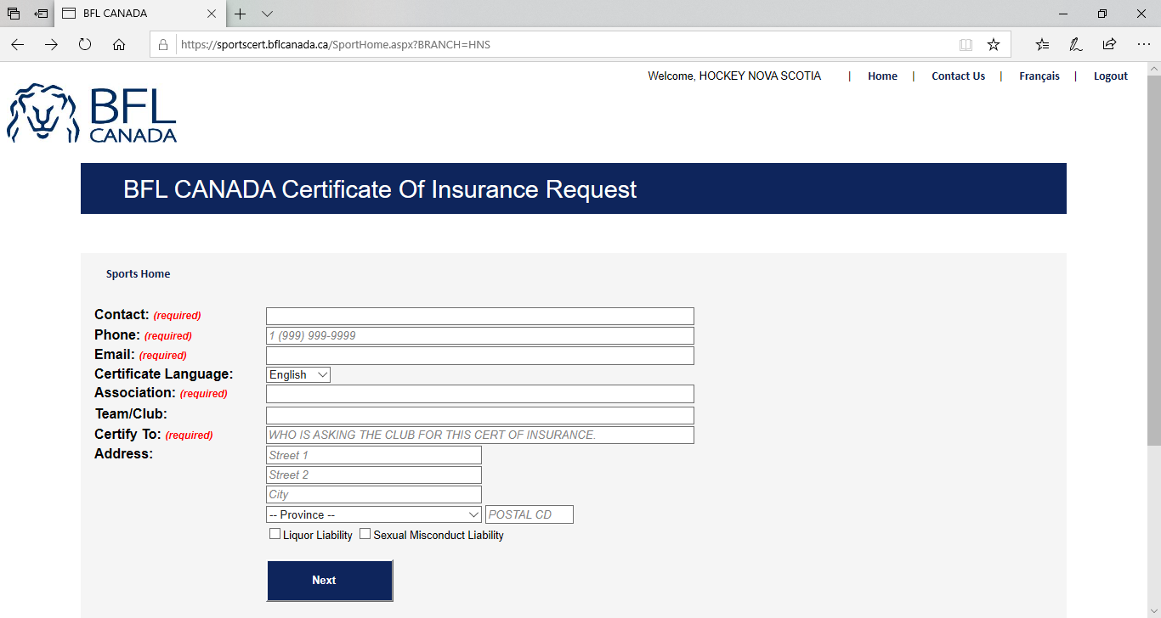
https://sportscert.bflcanada.ca/?BRANCH=HNS

The following form is to be completed in full and with as much detail as possible
- Full name
- Email
- Phone
- Association name
- Team name
- Who is asking for the certificate i.e.: Name of the facility
- Address of the facility

Click Next

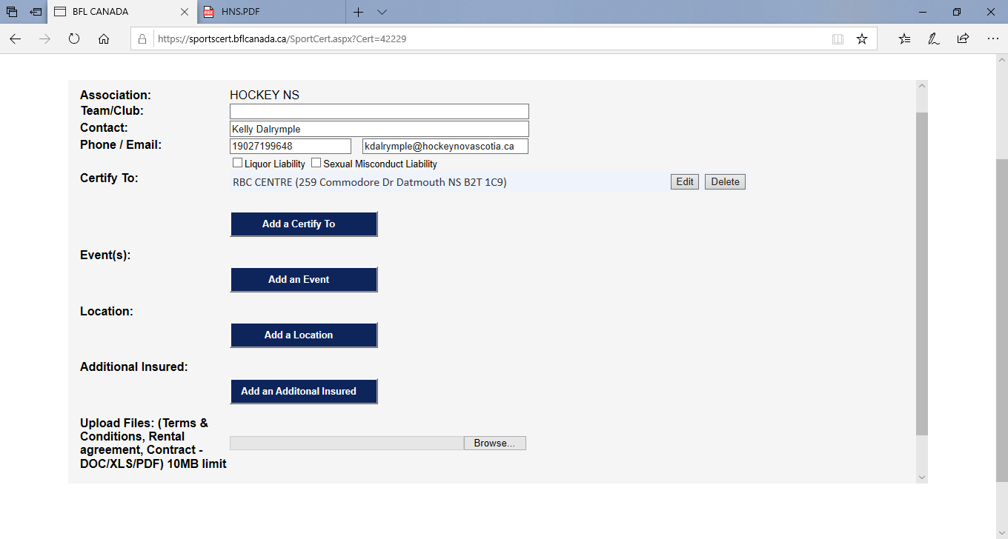
Some of the information will populate to this second form.
- Add an Event – be very specific as to the event and what you require the certificate for. (i.e. proof of insurance for a facility, dryland training, selling tickets for fund raising)
- Location – enter the location of the event.
- Additional Insured – Example RBC Centre and management services Nustadia Recreation needs to be on the certificate. Some facilities require numerous names to be stated on the certificate.
- Upload Files – If you have any files that need to be submitted with the request can be added here.

Please ensure that you have all the information entered before submitting your request to prevent a delay on receiving your proof of insurance certificate. Please allow up to 3 business days to receive these certificates. The certificate will be received by HNS and emailed to the applicant’s email address that was on the submission form.
If you have any questions or concerns, please contact Kelly Dalrymple at kdalrymple@hockeynovascotia.ca

